Name : Laiba Faisal

Roll Number: 213002

CODE:

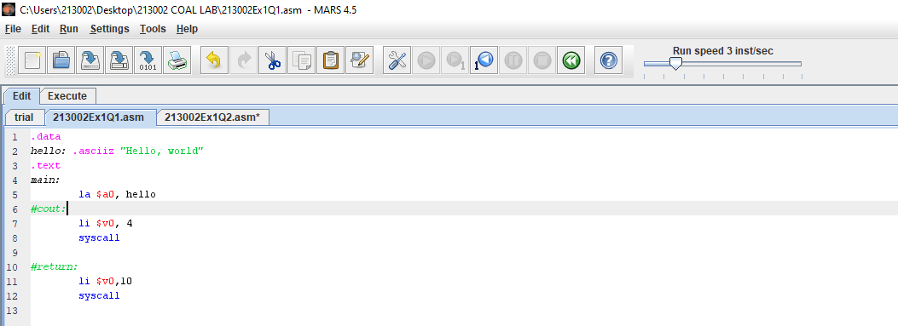

Q1. (b)

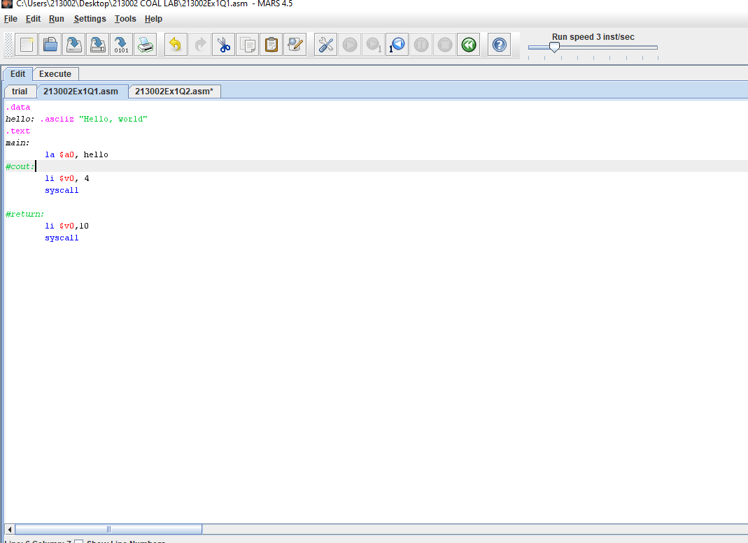

Q1 (d):

OUTPUT:

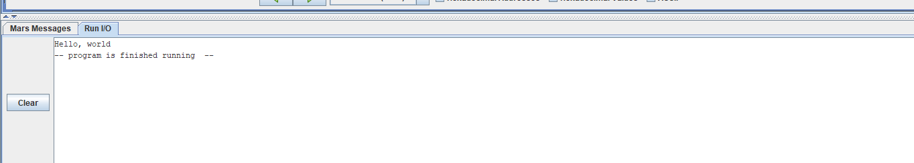

The output appears in the run I/O tab present below the execute window.

Q2 (b):

|  |  |  |
| --- | --- | --- |
| Initialised Data | Location | Value |
| Size | 0x00400010 | 12 |
| Fibs[0] | 0x10010000 | 1 |
| Fibs[1] | 0x10010004 | 1 |

Q2 ©:

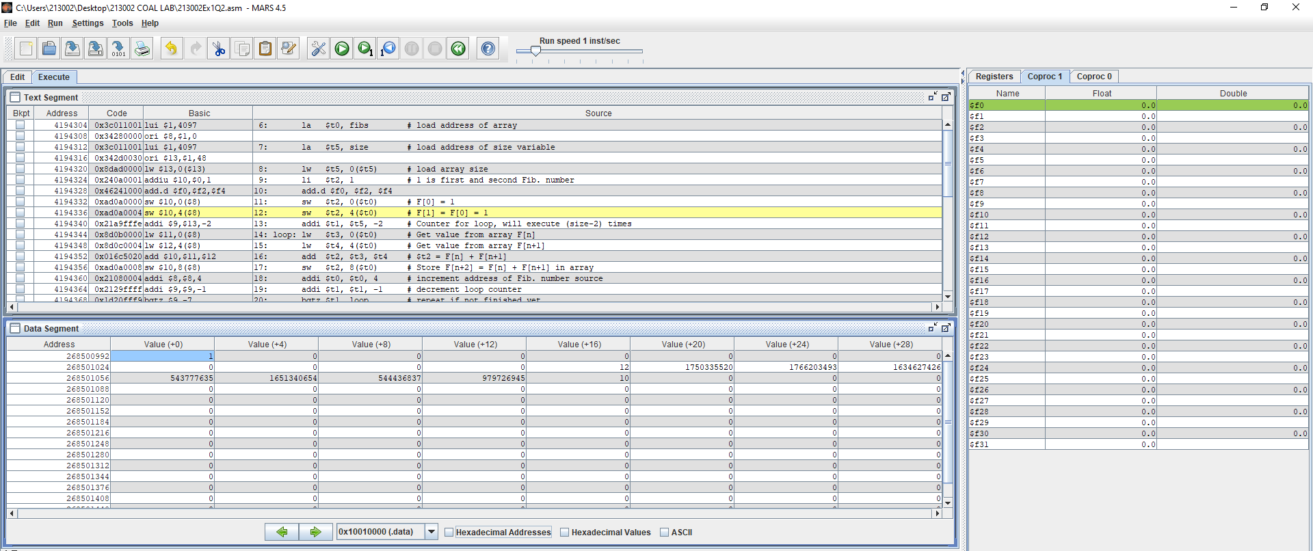

Q2 (d):

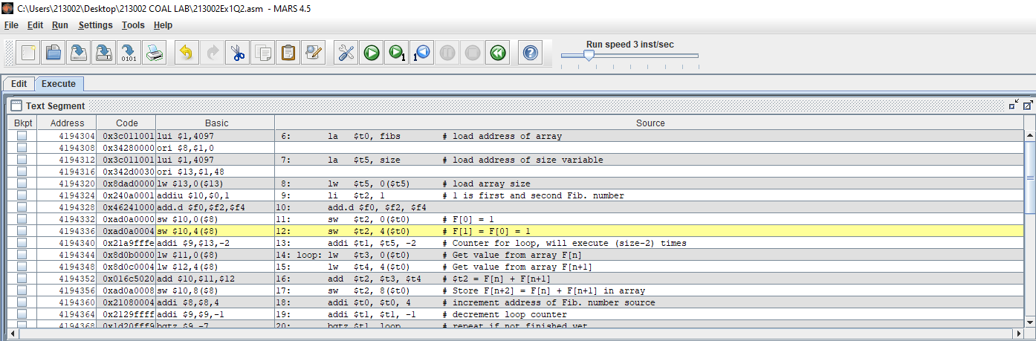

Q2 (e) :

LAB 2:

Q1:

CODE:

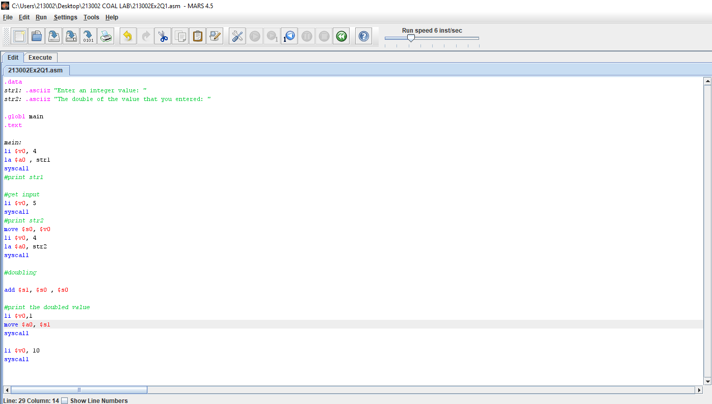

OUTPUT:

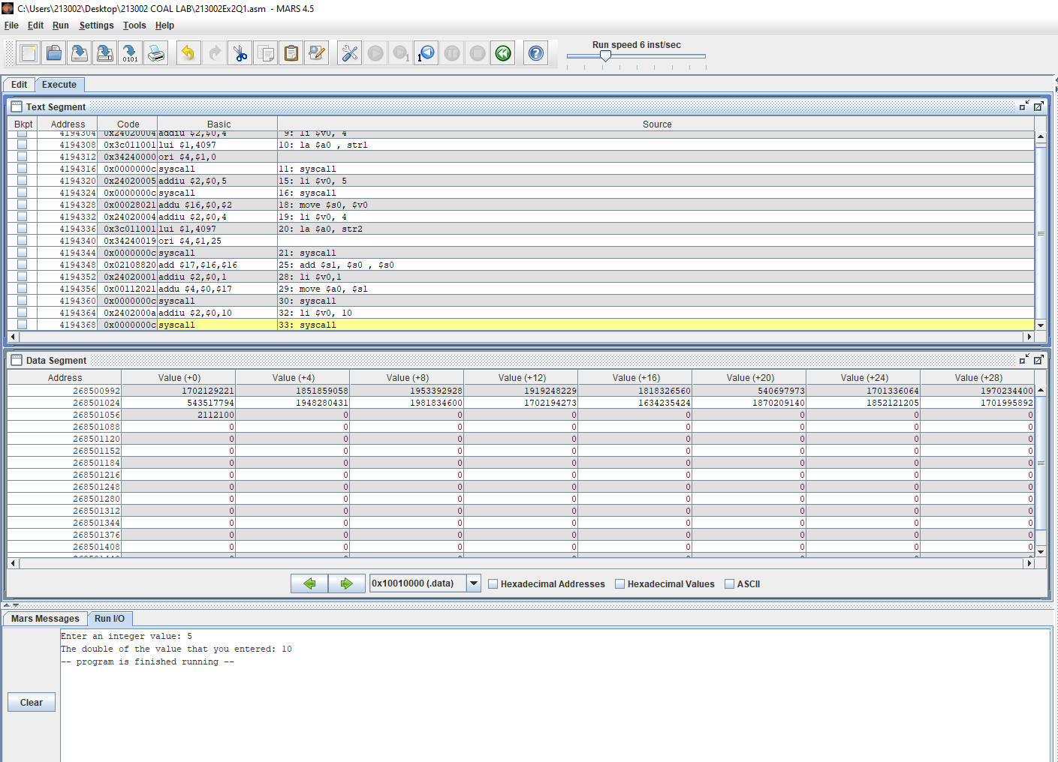

Q2:

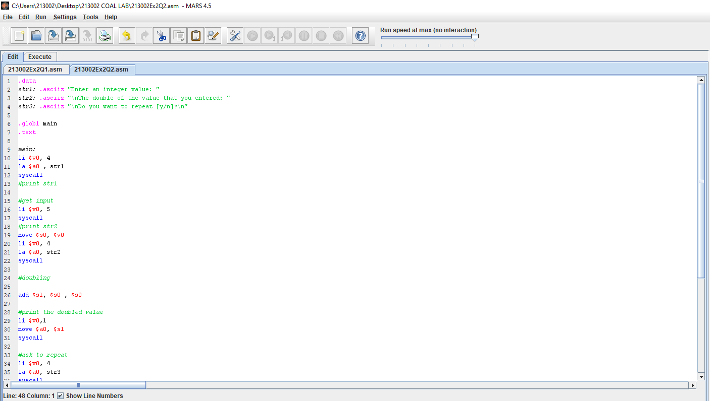

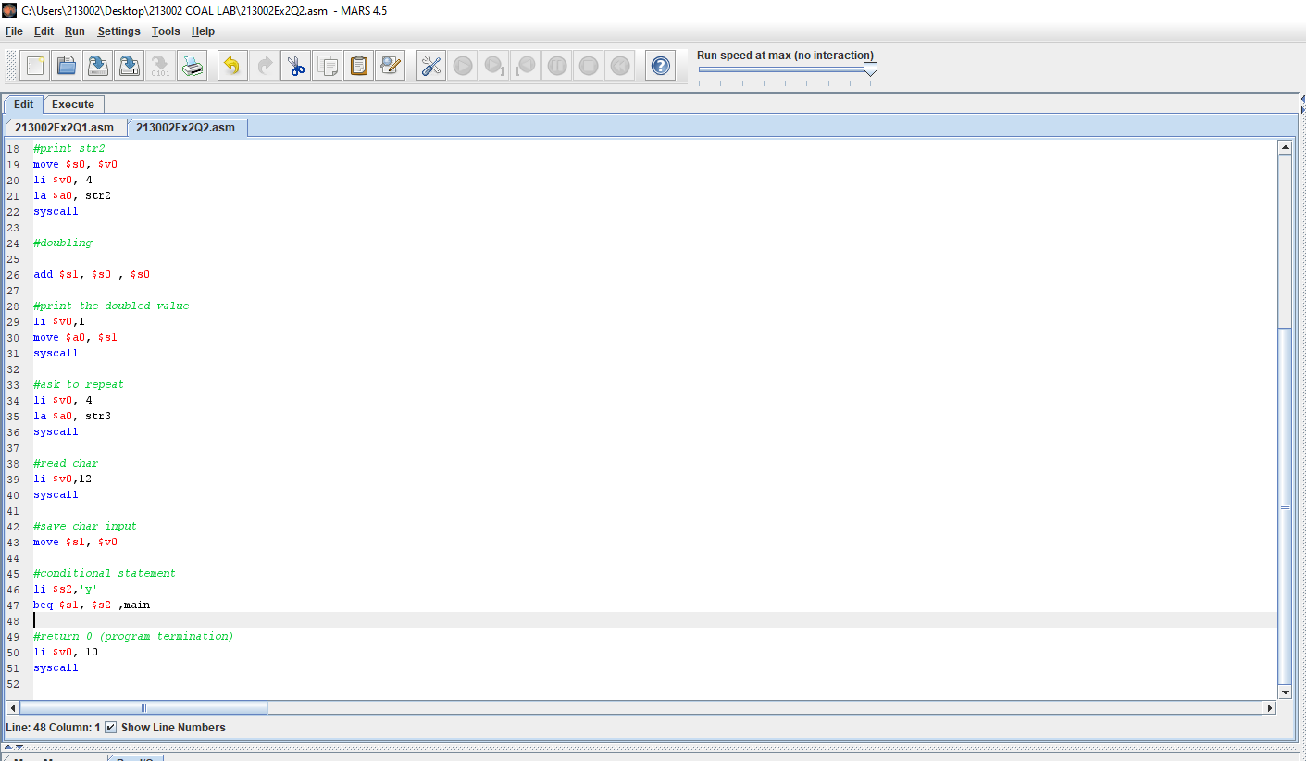

OUTPUT:

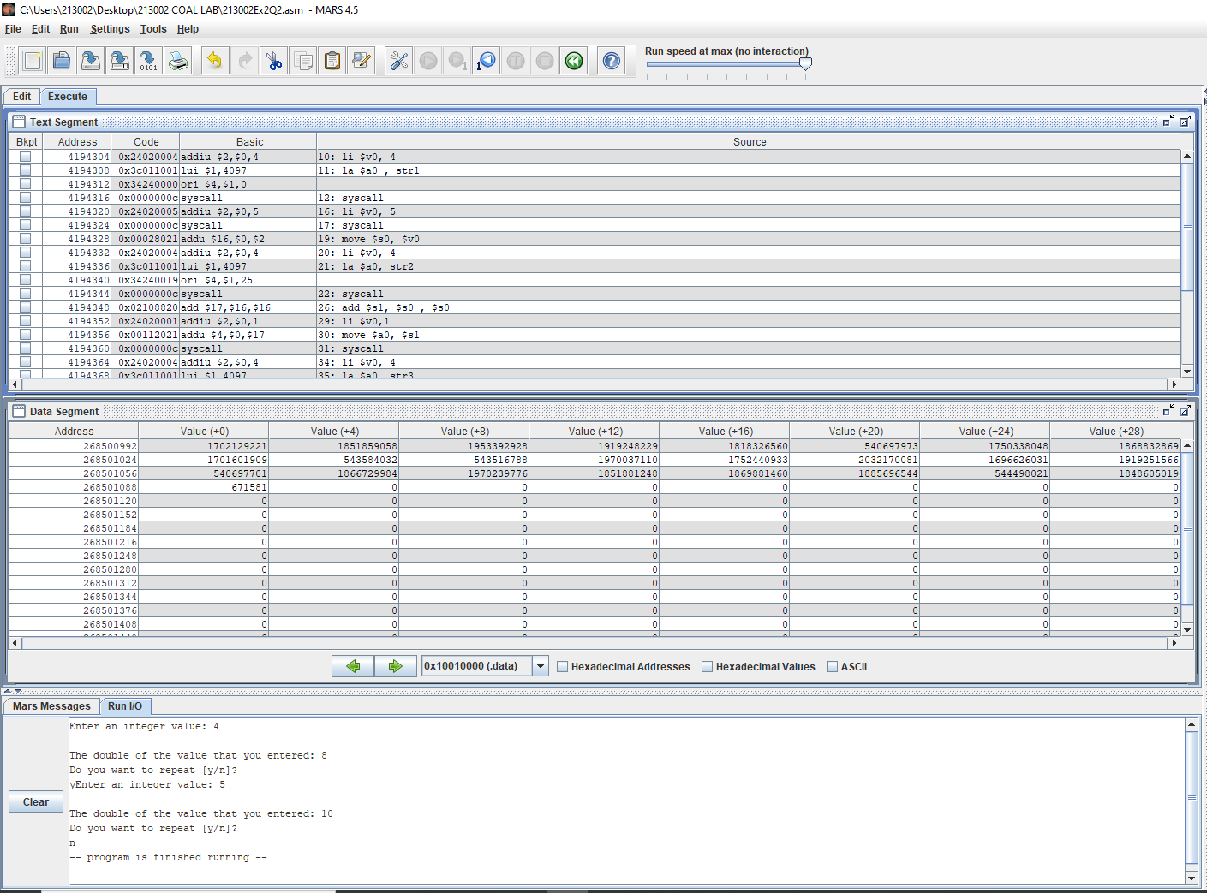

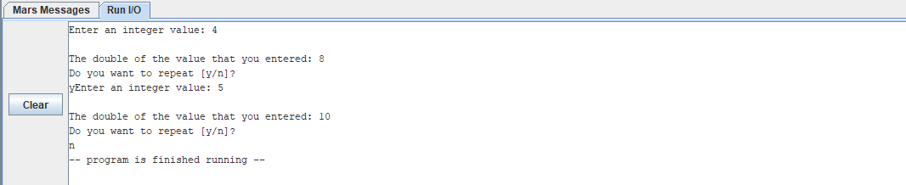

Q3:

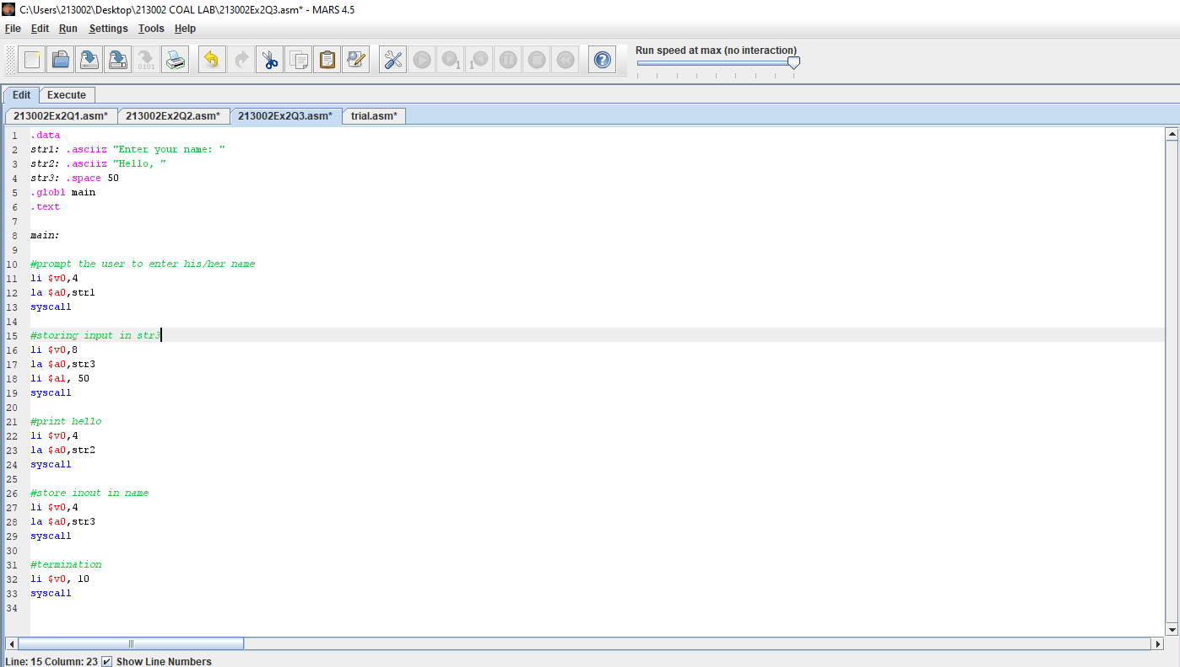

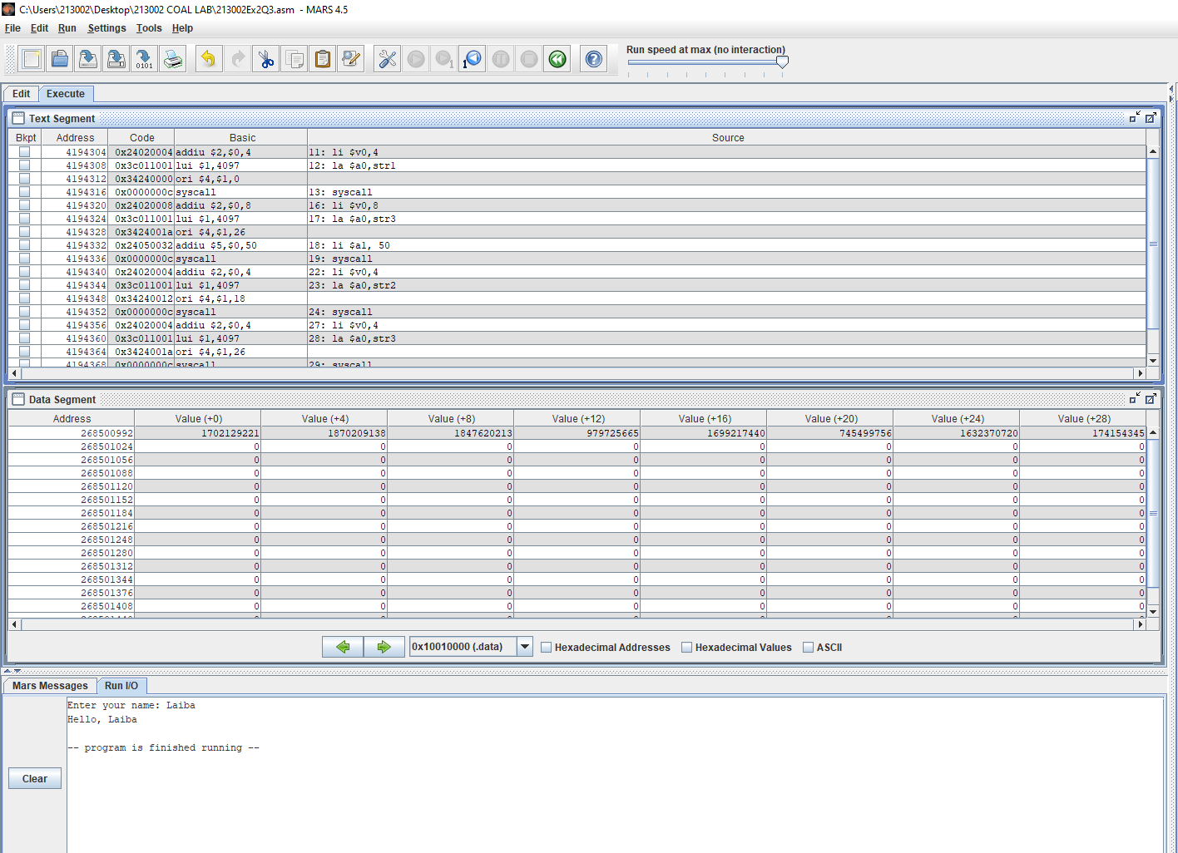

Q4:

Code:

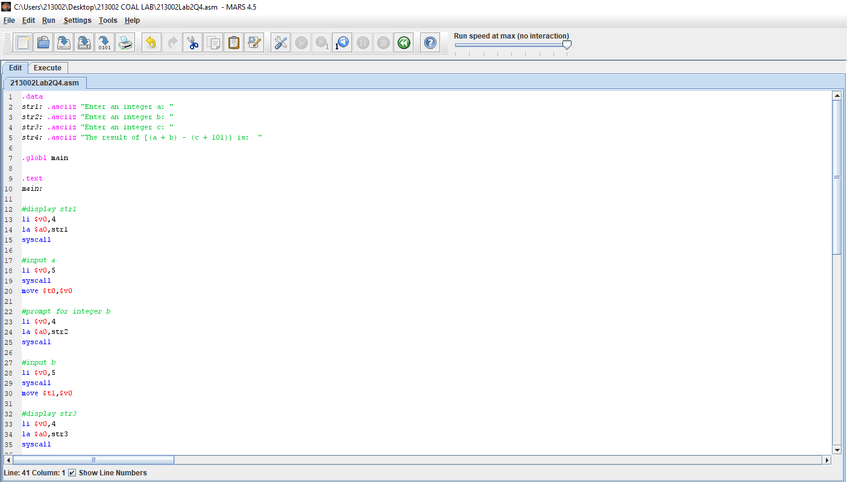

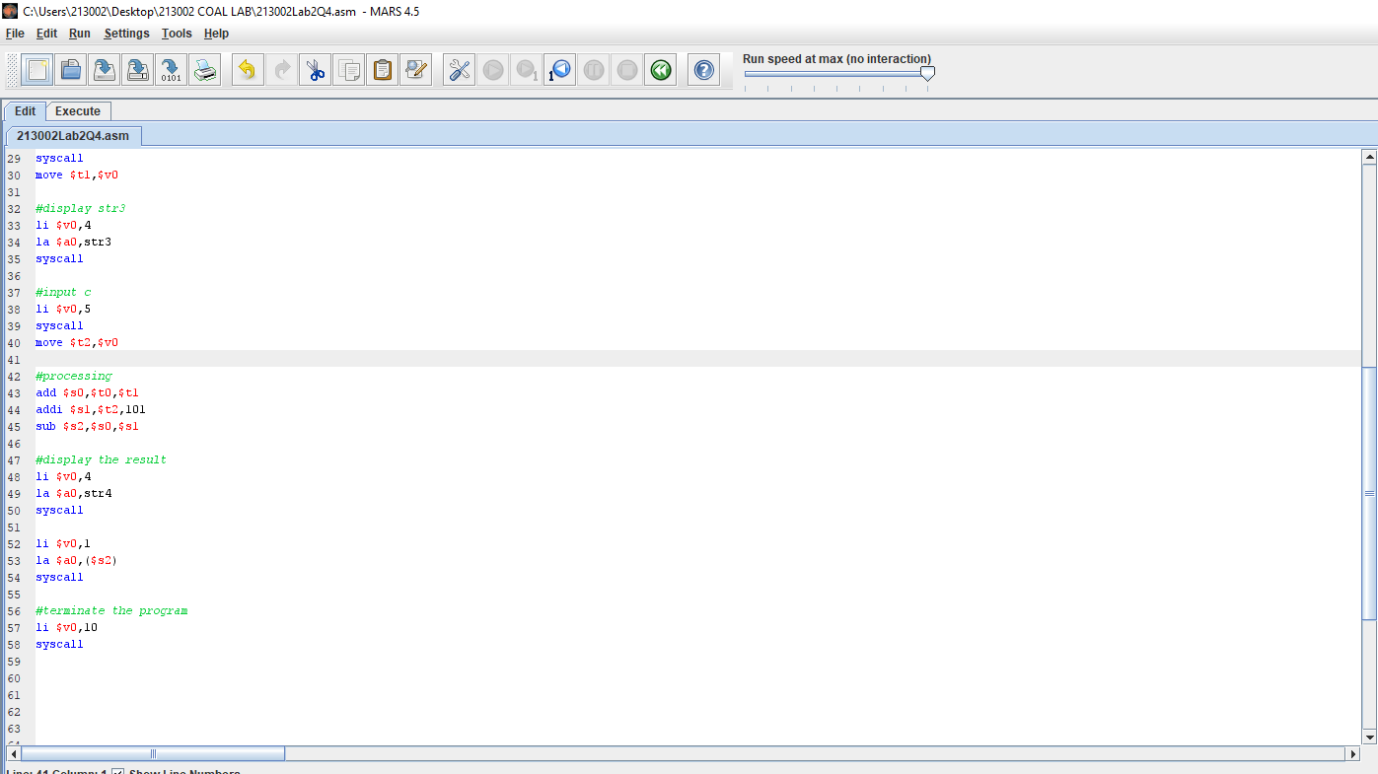

OUTPUT:

Q4 a): -56

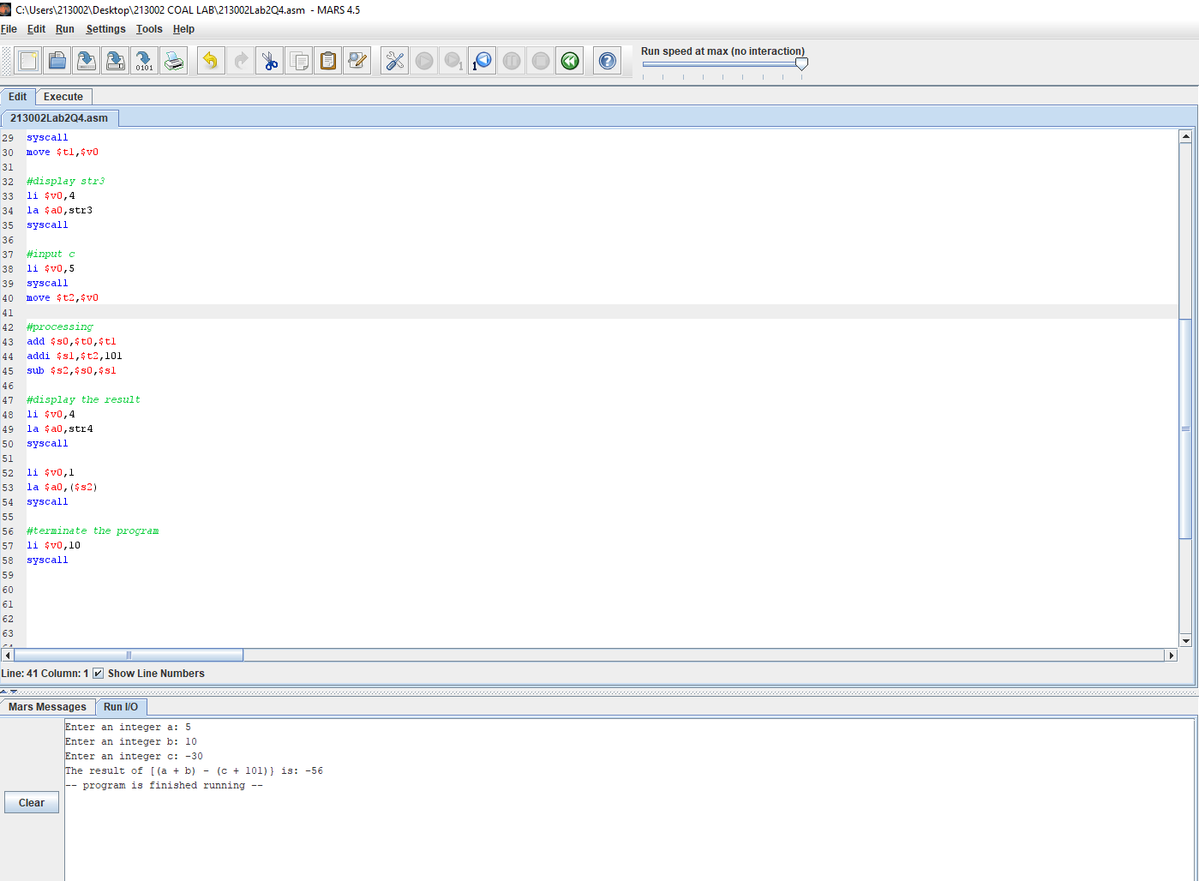

Q4. (b):

#processing

add $s0,$t0,$t1

addi $s1,$t2,101

sub $s2,$s0,$s1

These set of instructions performed the processing on the input and the final instruction sub, computed the value of s amd stored it in the register $s2.

Q4. (c):

0x0040005c

Q4. (d):

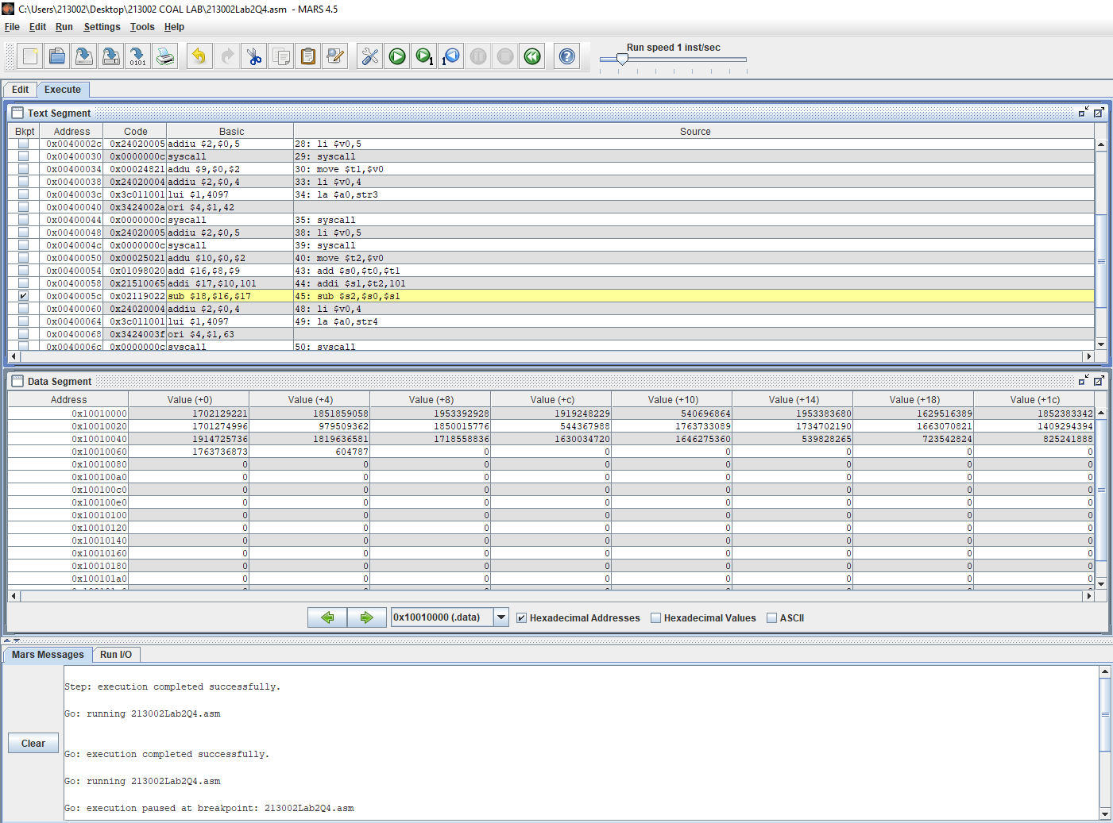

Breakpoint has been applied. The register $s1 in which the final computation took place has the value 1100 in decimal system and 0x0000044c in hexadecimal.

Q5:

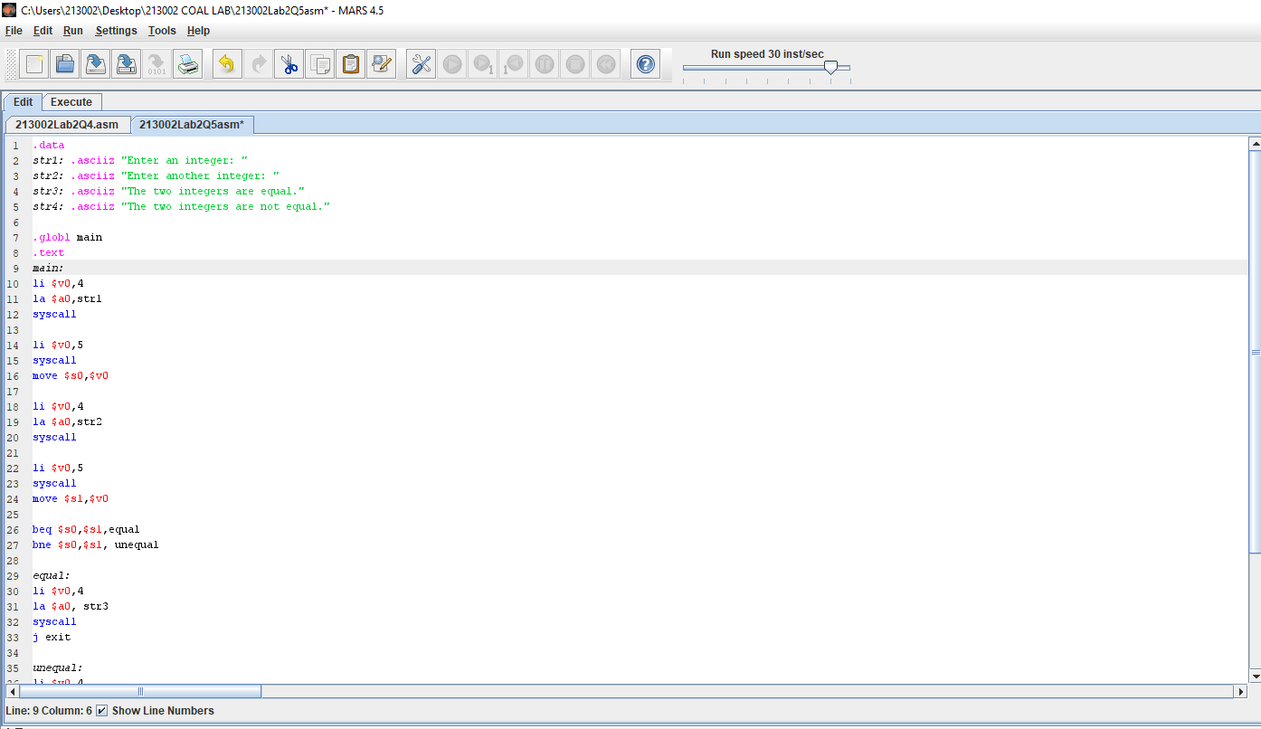

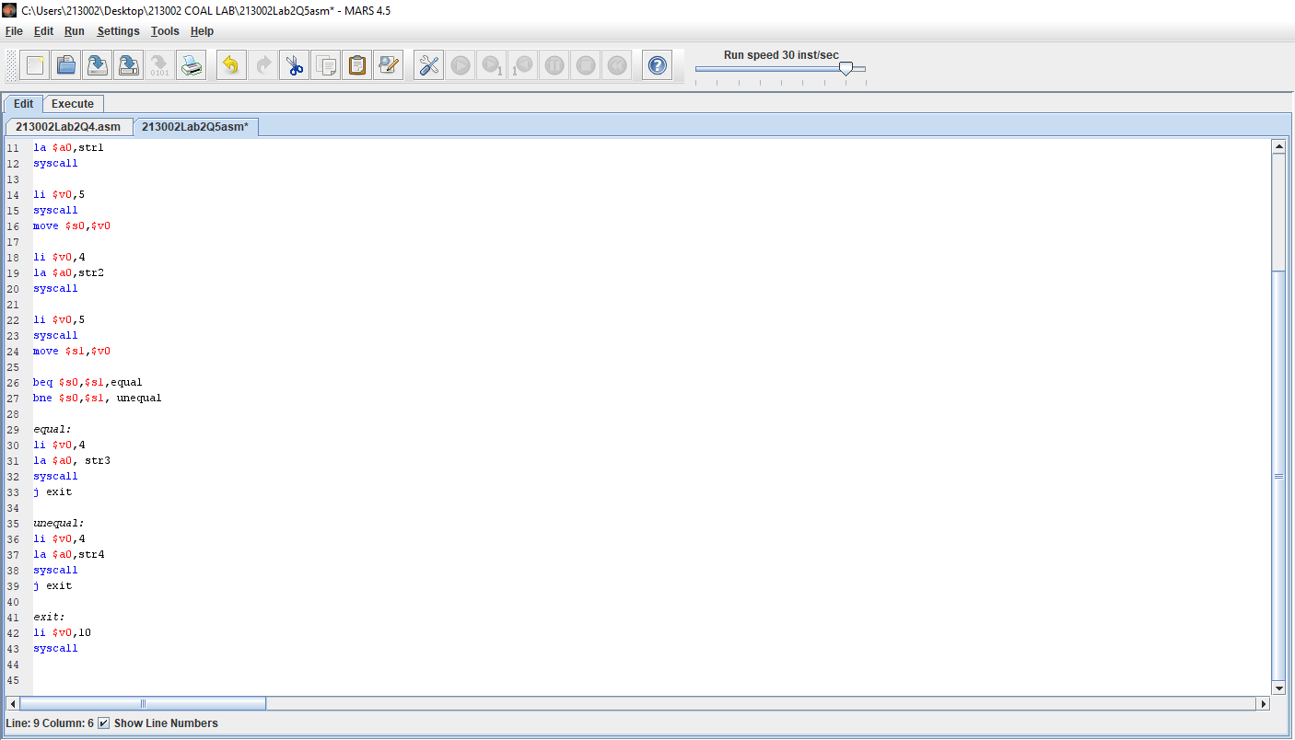

OUTPUT:

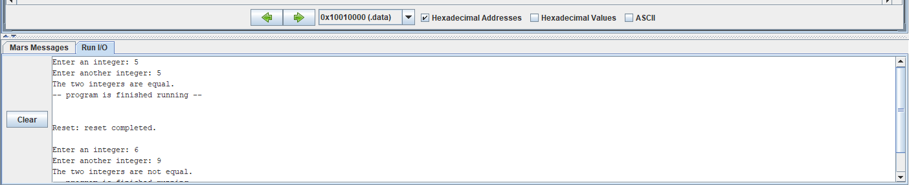

LAB 3

EXAMPLES:

Example 1:

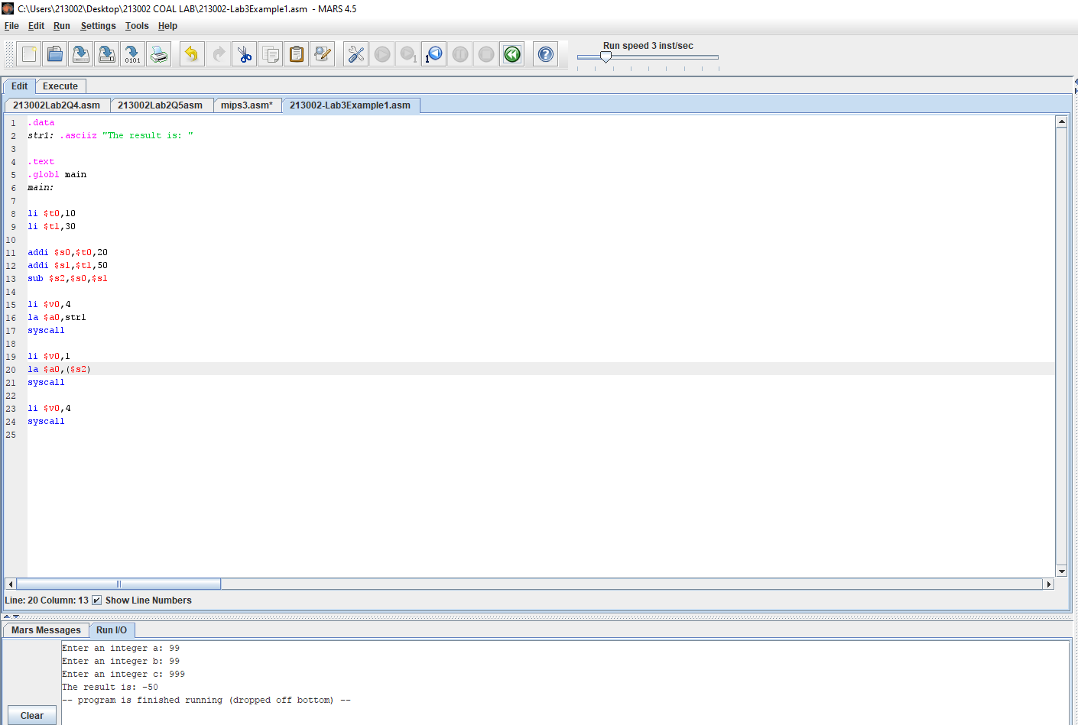

Example 2:

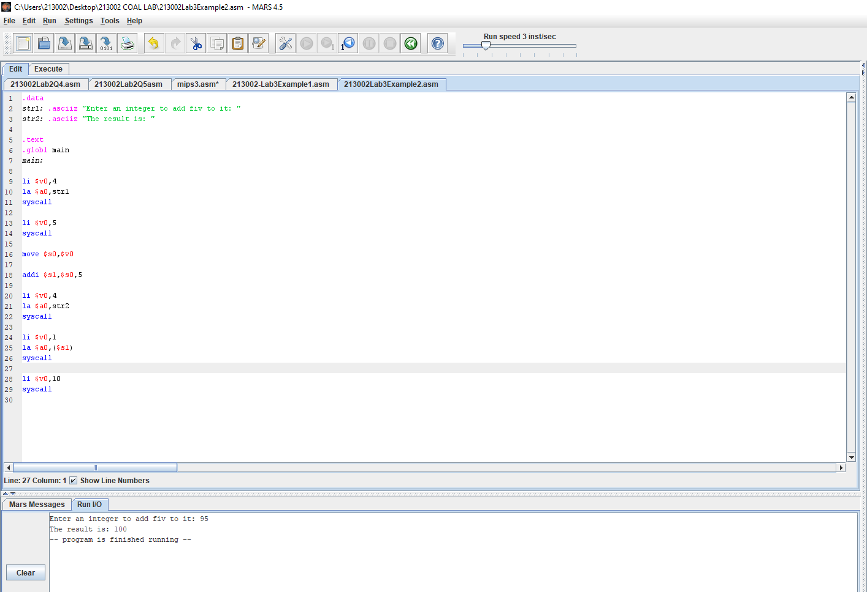

Example 3:

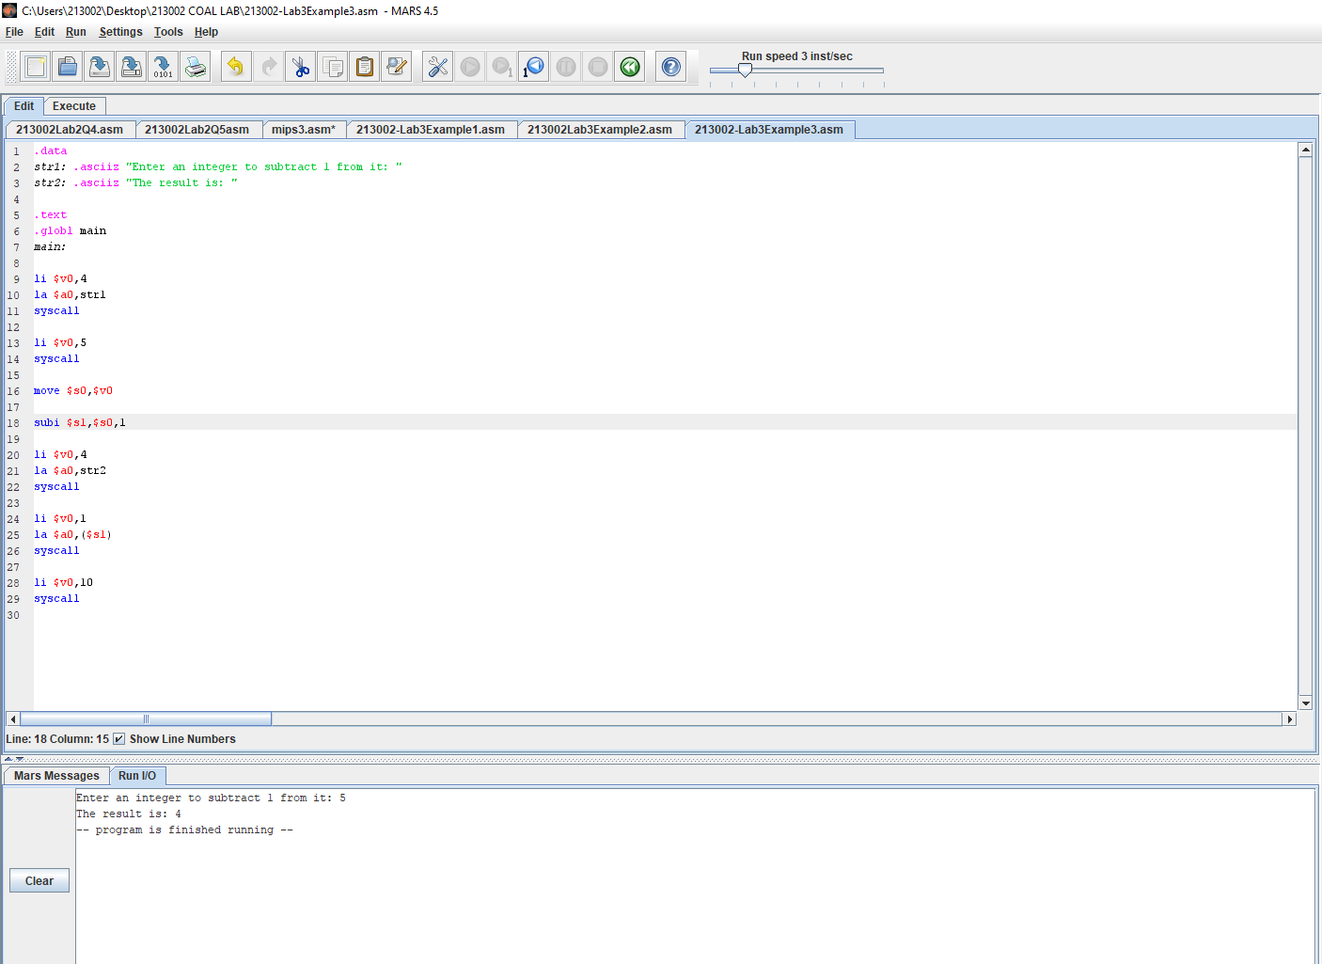

Example 4:

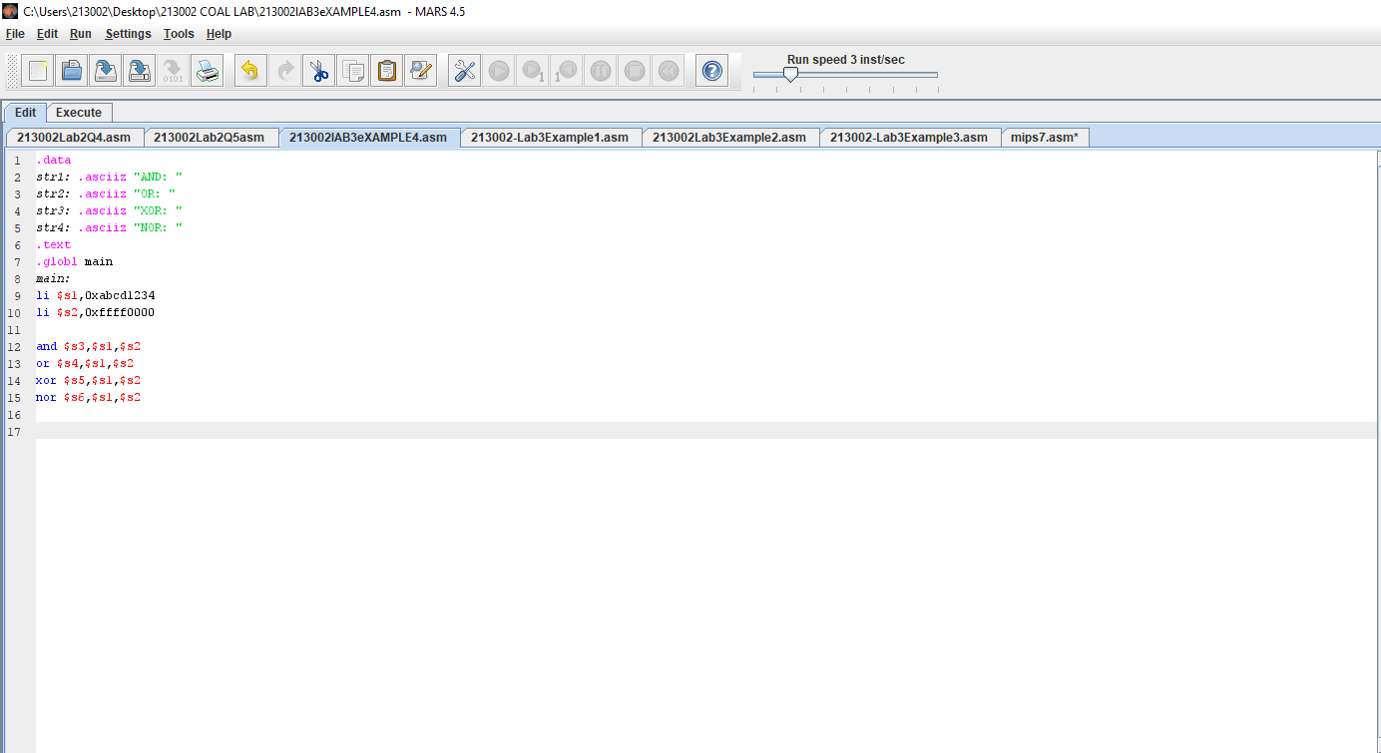

Q1:

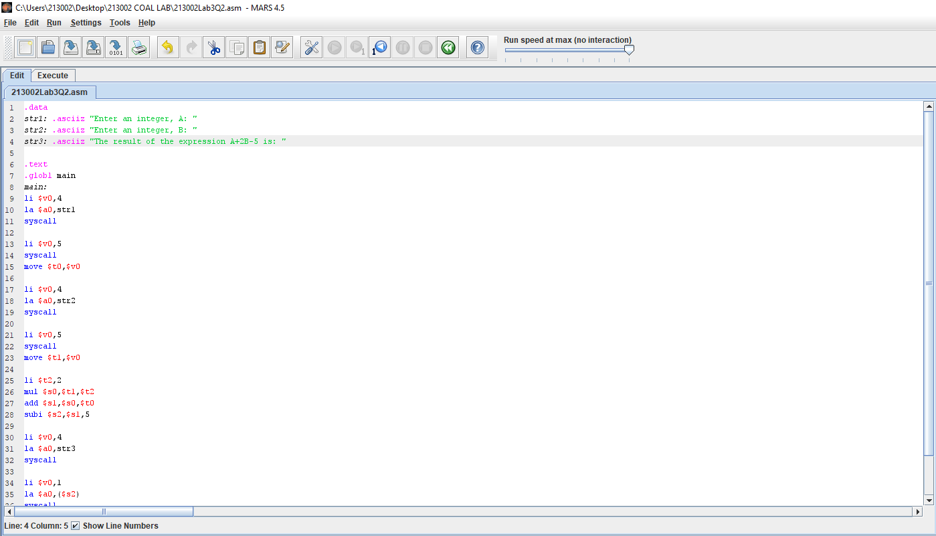

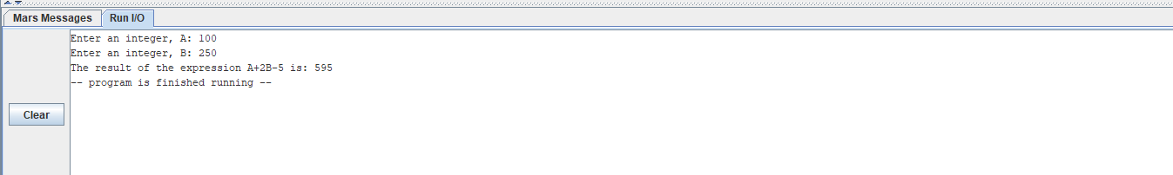

Question 2:

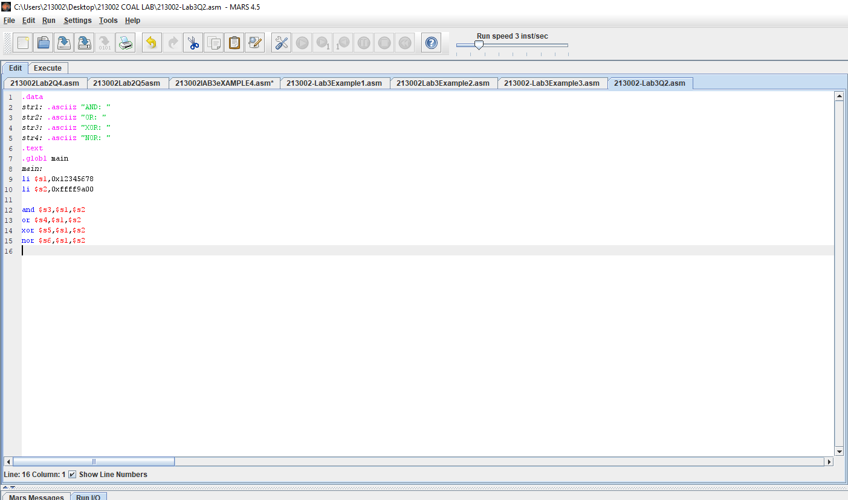

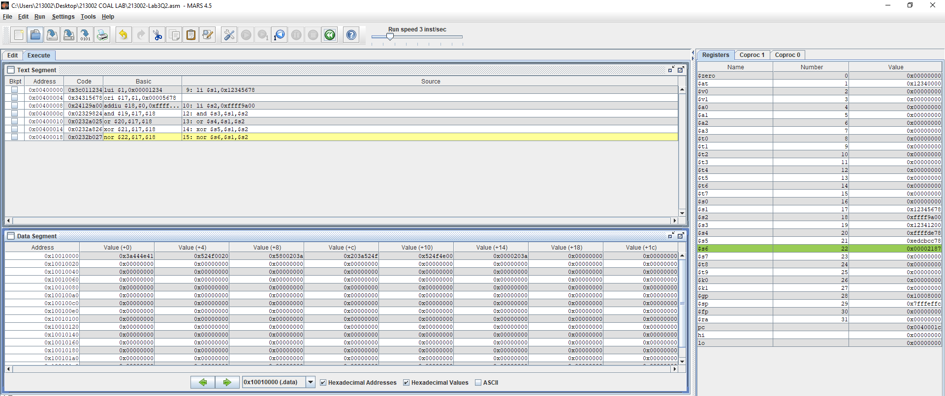

Question 3:

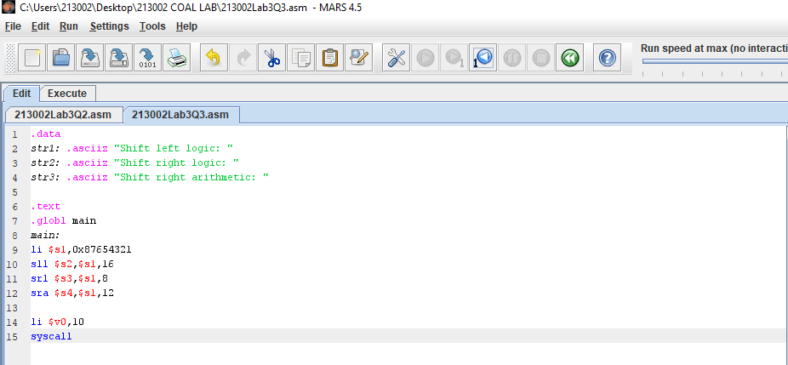

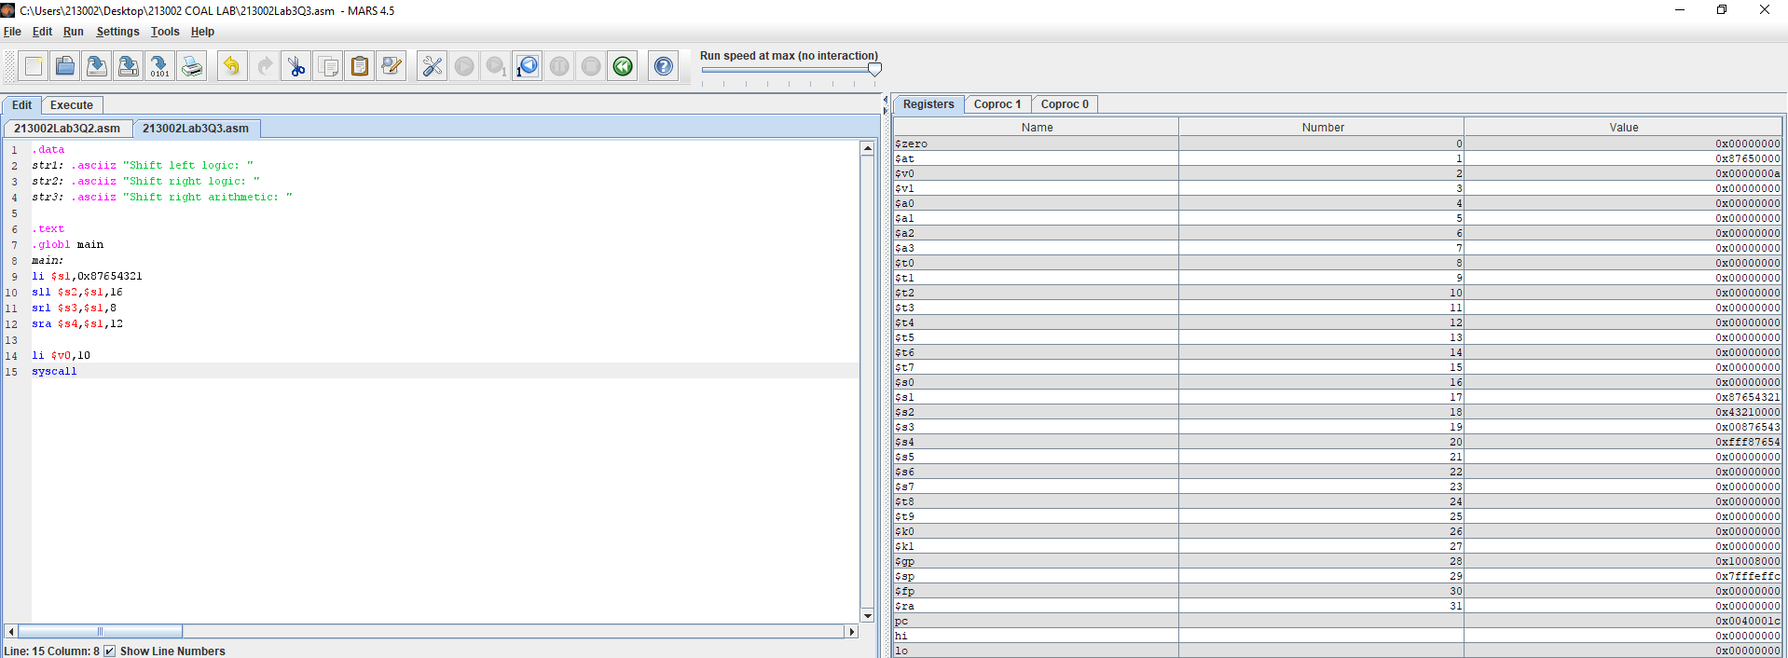

$s1 = 0x87654321

$s2 = 0x43210000

$s3 = 0x00876543

$s4 = 0xfff87654

Question 4:

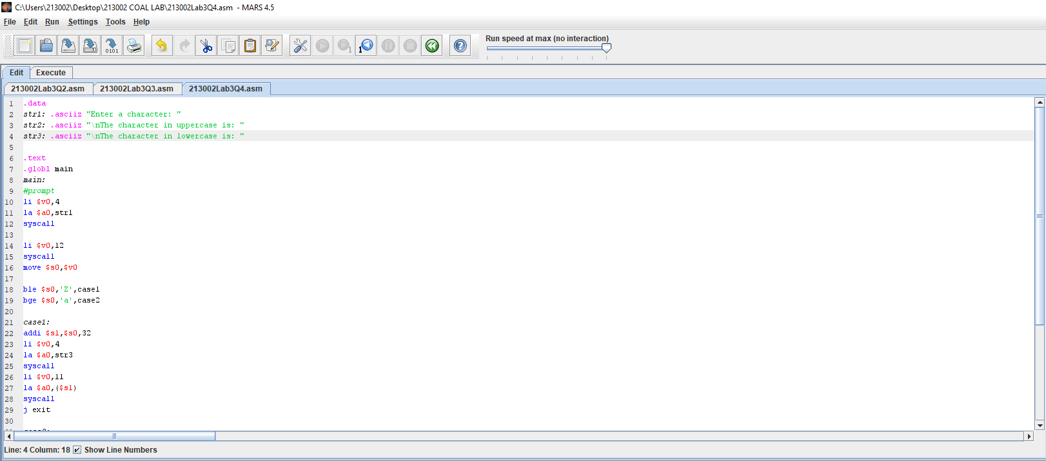

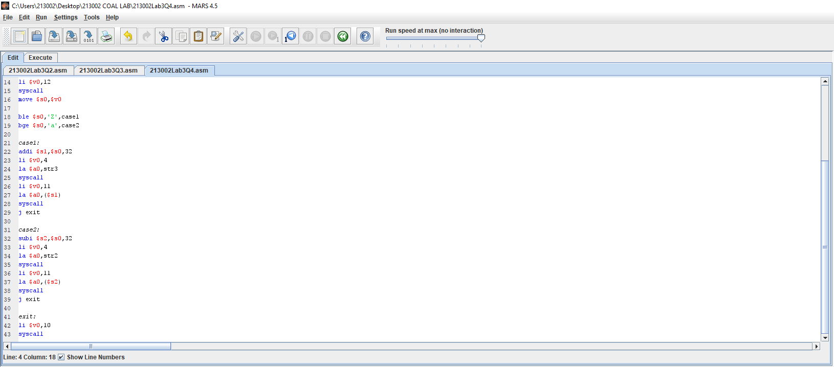

OUTPUT:

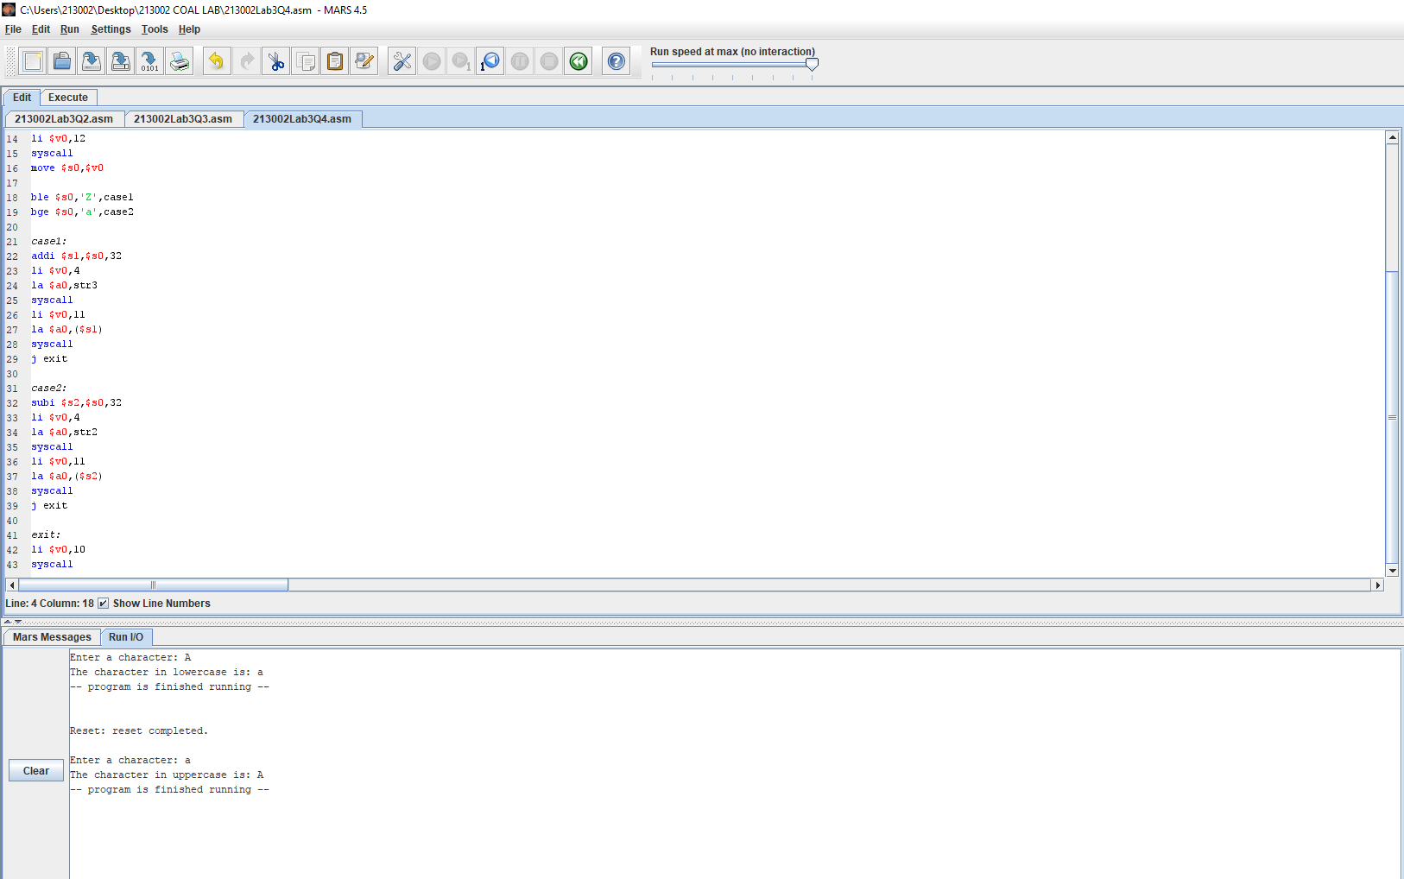

Question 5:

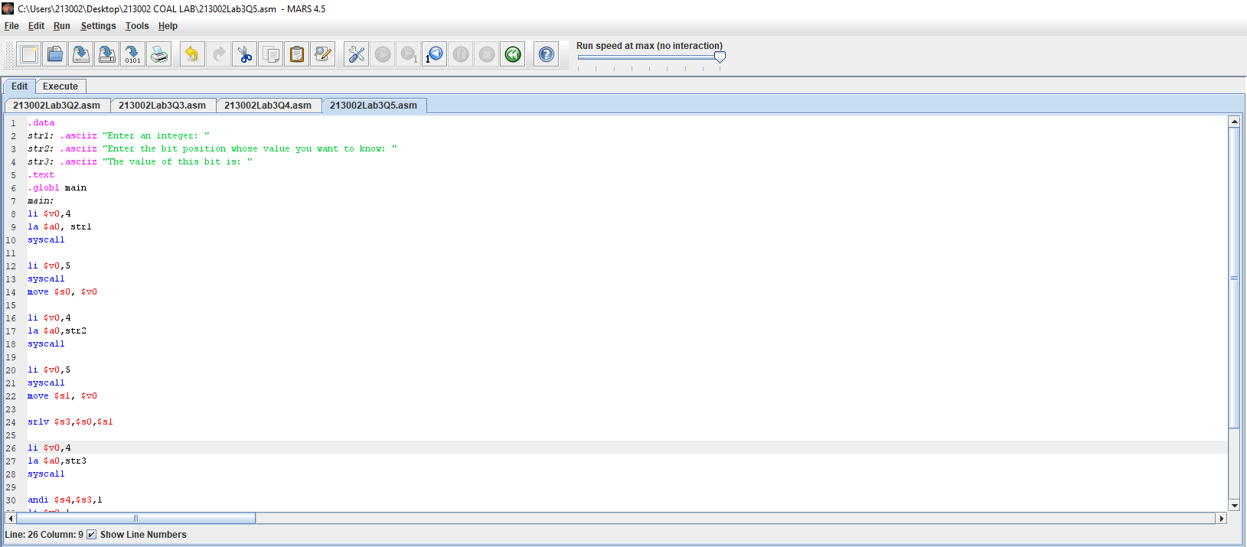

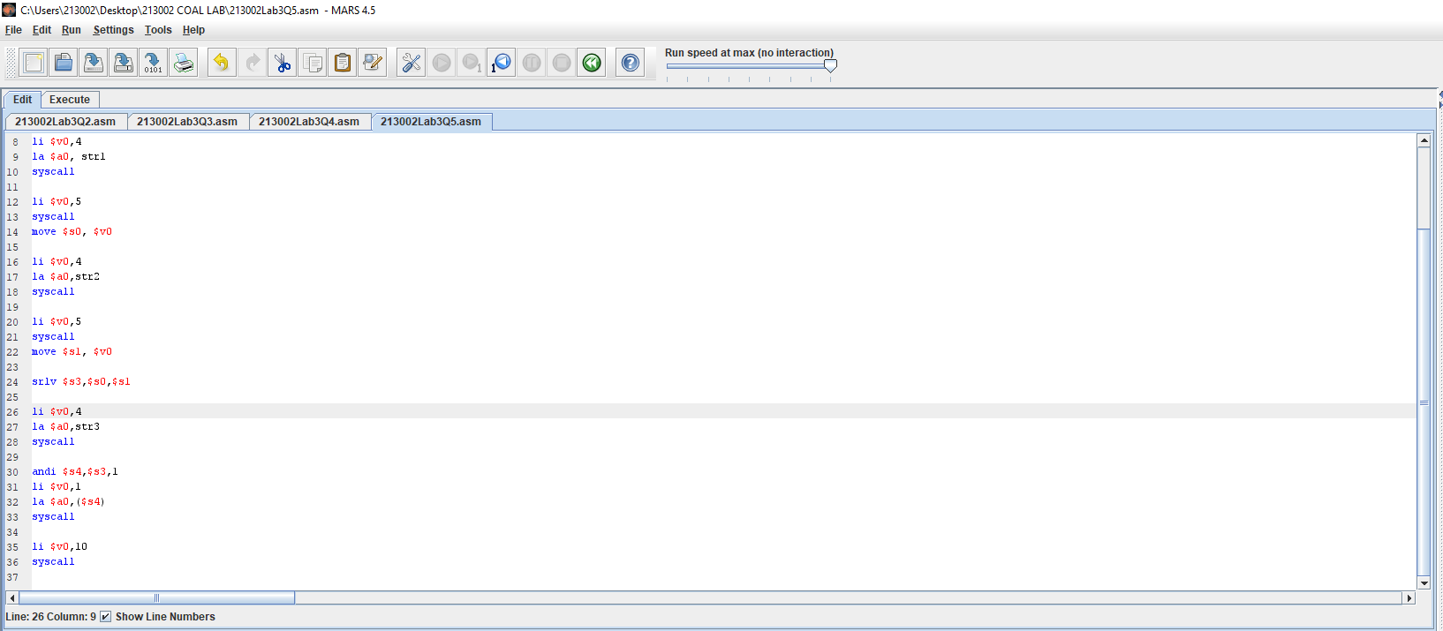

Output:

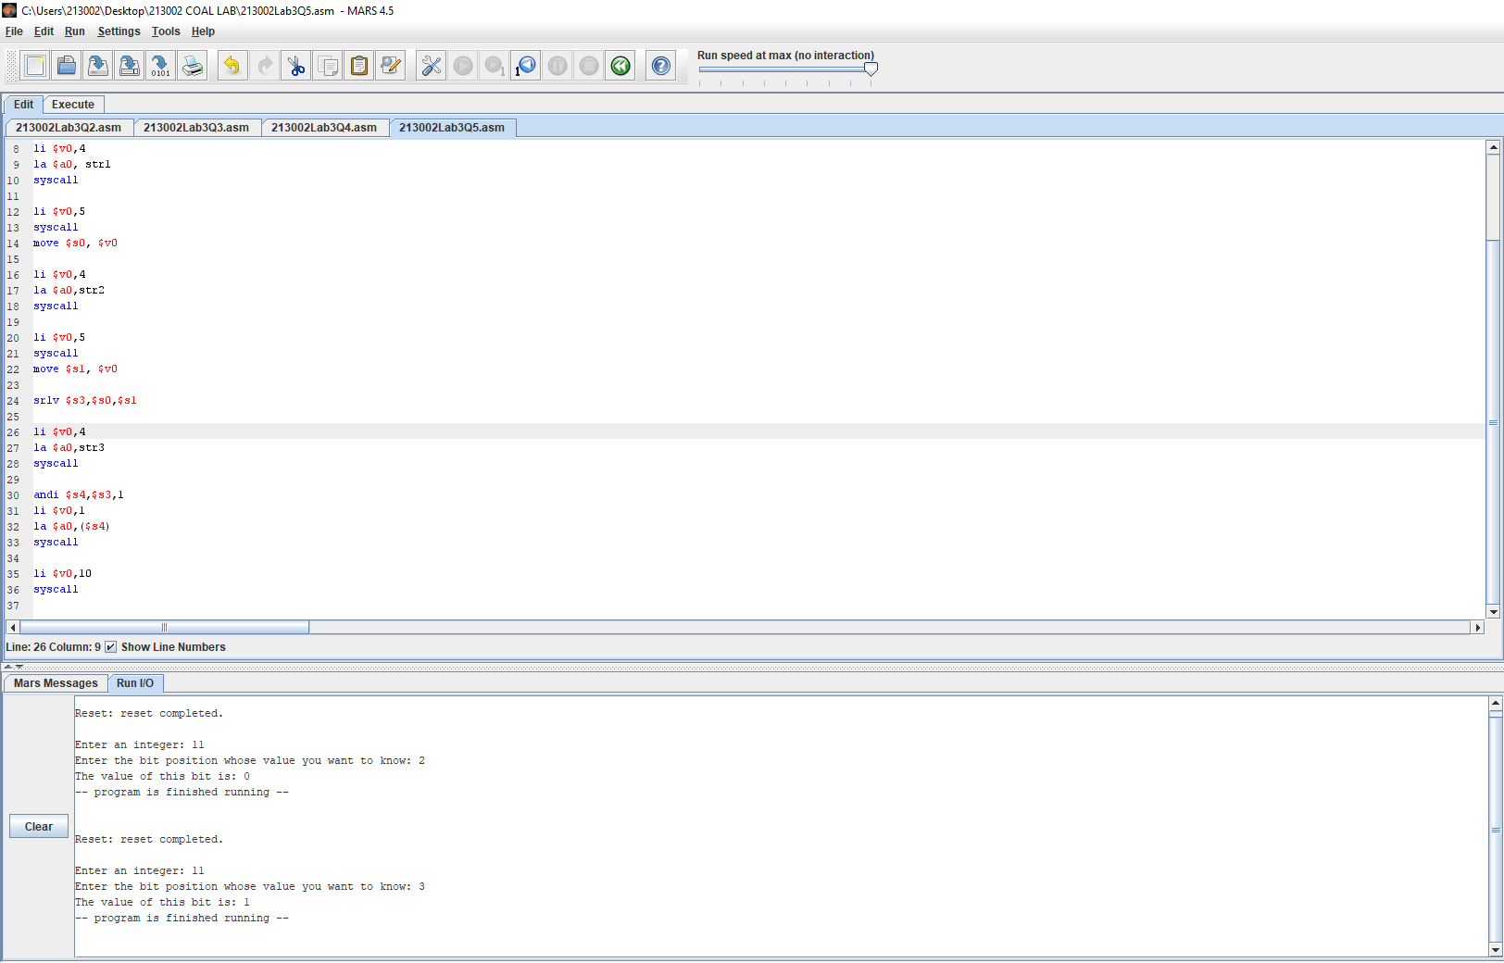

Question 6: